Medical Diagnosis Chatbot

Semester project

Session Fall 2024

BS in Artificial Intelligence



Department of Software Engineering

Faculty of Computer Science & Information Technology

The Superior University, Lahore

FALL 2024

|  |  |  |  |  |  |
| --- | --- | --- | --- | --- | --- |
| Type (Nature of project) | | | [ ✓ ] **D**evelopment [ ] **R**esearch [ ] **R**&**D** | | |
| Area of specialization | | | Chatbot in Ai | | |
| **Project Group Members** | | | | | |
| Sr.# | Reg. # | Student Name | | Email ID | *Signature |
| (i) | 087 | Syed Ahmed Iqbal | | dev.iqbal3@gmail.com |  |
| (ii) |  |  | |  |  |
| (iii) |  |  | |  |  |

*The candidates confirm that the work submitted is their own and appropriate credit has been given where reference has been made to work of others

# Table of Contents

Introduction v

Tools and Technologies 4viii

Implementation and Code 7x

Results 9xiii

# 

# List of Figures

1.1 Code snippet 1 6

1.2 Code snippet 2 7

1.3 Code snippet 3 14

2.0 Result 22

# Chapter 1

# Introduction

# Write Introduction about your project

### ****Overview****

This project introduces an AI-powered conversational assistant designed to provide general medical information and support users seeking health-related guidance. By leveraging cutting-edge natural language processing (NLP) and advanced AI models, the assistant ensures clarity, empathy, and evidence-based responses while respecting ethical considerations and confidentiality. The assistant is not a substitute for professional medical advice but serves as a helpful intermediary for general health information and wellness education.

### ****Objective****

The primary objective of this project is to create an intelligent, responsive, and context-aware chatbot capable of:

1. **Understanding medical queries:** The assistant uses NLP techniques to identify and respond appropriately to health-related questions.
2. **Providing accurate information:** Responses are grounded in clear, concise, and general medical knowledge.
3. **Maintaining user focus:** Ensuring users remain informed about the assistant's limitations, with clear disclaimers emphasizing consultation with licensed professionals for critical concerns.
4. **Promoting health awareness:** Encouraging preventive care and general wellness practices, while supporting users with empathetic and respectful communication.

### ****Key Features****

1. **Natural Language Understanding:**
   * **SpaCy Integration:** The assistant uses the SpaCy library to analyze user input and identify whether a query is medical in nature. The NLP model is fine-tuned with a threshold-based similarity metric to distinguish health-related content.
   * **Medical Terminology Matching:** Core medical terms, loaded from an external file, help determine whether user queries fall within the assistant's domain.
2. **AI-Driven Responses:**
   * **Ollama LLM Integration:** Responses are generated using a powerful language model (gemma:2b), fine-tuned for conversational accuracy and relevance.
   * **Dynamic Context Management:** The assistant maintains a rolling conversational history of up to five turns, ensuring responses are contextually relevant without overloading the model.
3. **Ethical and Empathetic Guidelines:**
   * **Role Specification:** The AI explicitly assumes the role of a knowledgeable medical assistant, carefully distinguishing itself from licensed healthcare providers.
   * **Disclaimers and Recommendations:** Every response includes a disclaimer and suggestions to consult professionals for critical or emergency issues.
4. **Error Handling and Logging:**
   * Logging mechanisms record conversation details and potential errors for debugging and performance analysis.
   * User feedback is collected at the end of the session to evaluate and improve the system's effectiveness.
5. **User-Friendly Interface:**
   * An intuitive command-based interaction allows users to exit sessions gracefully or provide feedback about their experience.

### ****Technological Stack****

1. **Programming Language:** Python
2. **Libraries and Tools:**
   * **Natural Language Processing:** SpaCy (en_core_web_md)
   * **Large Language Model (LLM):** Ollama LLM (gemma:2b)
   * **Logging:** Python's built-in logging module
3. **Data Input:** External text file containing core medical terms (medical_term.txt)
4. **Conversation Management:** Context-tracking with turn-based dialogue history for improved coherence.

### ****Use Cases****

1. **Health Education:**
   * Provide users with general information about symptoms, preventive care, and common treatments.
2. **Supportive Conversations:**
   * Encourage wellness practices and mental health awareness in a non-judgmental and culturally sensitive manner.
3. **Information Gateway:**
   * Guide users to seek professional help or emergency services for severe or ambiguous concerns.

### ****Conclusion****

This AI-powered medical query assistant demonstrates the potential of combining advanced AI models with ethical design principles to address general health-related questions effectively. It aims to bridge the gap between users and medical resources, fostering awareness and proactive health management while acknowledging its limitations and prioritizing safety.

# Chapter 2

# Tool & Technology

# Write tool and technology which you have used

### ****Tools and Technologies Used in the Project****

This project combines advanced AI models, natural language processing libraries, and Python-based utilities to build a reliable and user-friendly medical query assistant. Below is a breakdown of the tools and technologies employed:

### ****Programming Language****

* **Python**: The primary language used for its simplicity, versatility, and wide range of libraries for NLP and AI.

### ****Natural Language Processing****

* **SpaCy**:
  + Used to process and analyze user input.
  + The en_core_web_md model enables accurate word embeddings, similarity comparisons, and context analysis for identifying medical-related queries.
  + Facilitates matching user input with preloaded medical terms for domain-specific focus.

### ****AI and Language Models****

* **Ollama LLM (gemma:2b)**:
  + Provides AI-driven responses to user queries.
  + Fine-tuned for conversational relevance and contextual understanding, ensuring clear and accurate information delivery.
  + Supports dynamic interaction, generating topic-specific responses while adhering to ethical guidelines.

### ****File and Data Handling****

* **Medical Terms File (medical_term.txt)**:
  + A plain-text file containing a curated list of medical terms.
  + Used to preload domain-specific vocabulary, aiding in the identification of medical questions.

### ****Context Management****

* **Rolling Context Implementation**:
  + Tracks the last five user interactions to maintain conversational coherence.
  + Ensures that responses are relevant to the ongoing discussion without overwhelming the AI model.

### ****Error Logging and Monitoring****

* **Python logging Module**:
  + Used to log errors, responses, and user feedback.
  + Helps monitor system performance and identify issues during runtime.

### ****Dynamic Prompt Construction****

* **LangChain Framework**:
  + Utilized for creating structured and customizable chat prompts.
  + Enables seamless integration of templates with AI models to maintain a consistent conversational flow.

### ****Ethical and User-Focused Design****

* **Guidelines and Disclaimers**:
  + Hardcoded in the system to ensure transparency about the AI's role and limitations.
  + Promotes safe use and encourages professional consultation for serious concerns.

### ****User Interface****

* **Command-Line Interface (CLI)**:
  + Provides a straightforward and accessible environment for users to interact with the assistant.
  + Allows for quick feedback and graceful session termination with commands like "Exit."

### ****Feedback Collection****

* **User Feedback System**:
  + Integrated at the end of each session to collect qualitative input (e.g., Excellent, Good, Fair, Poor).
  + Feedback logs are stored using the logging module to inform future improvements.

### ****Laptop specifications:****

* Core i5 1135g7
* 16gb ram
* 256gb nvme gen 3 ssd

# Chapter 3

# Implementation Code

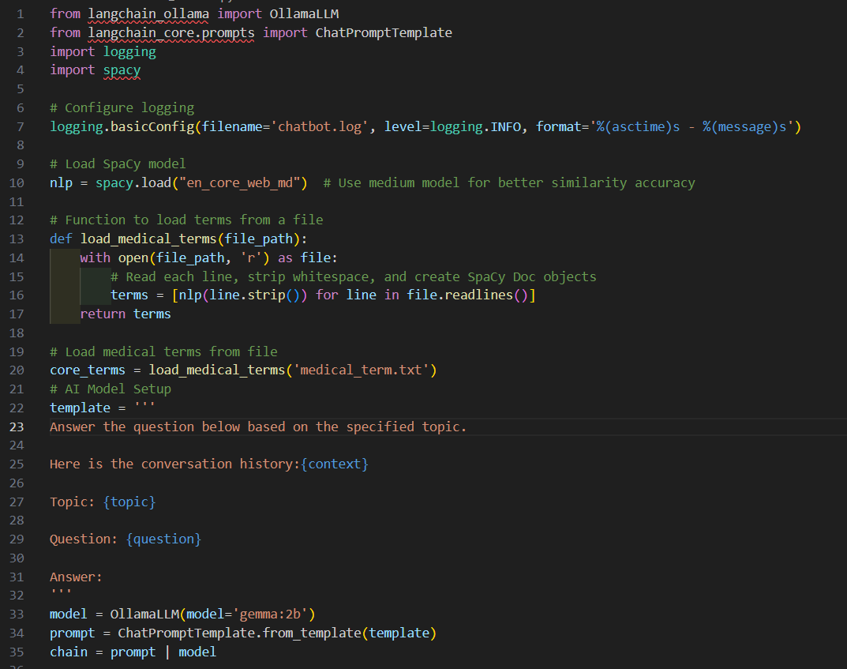

Figure .1 code snippet 1

Context:

In the above snippet, necessary libraries are being imported , NLP is being implemented as the medical terms for verification are being loaded. Also a template is defined for the chatbot to understand .

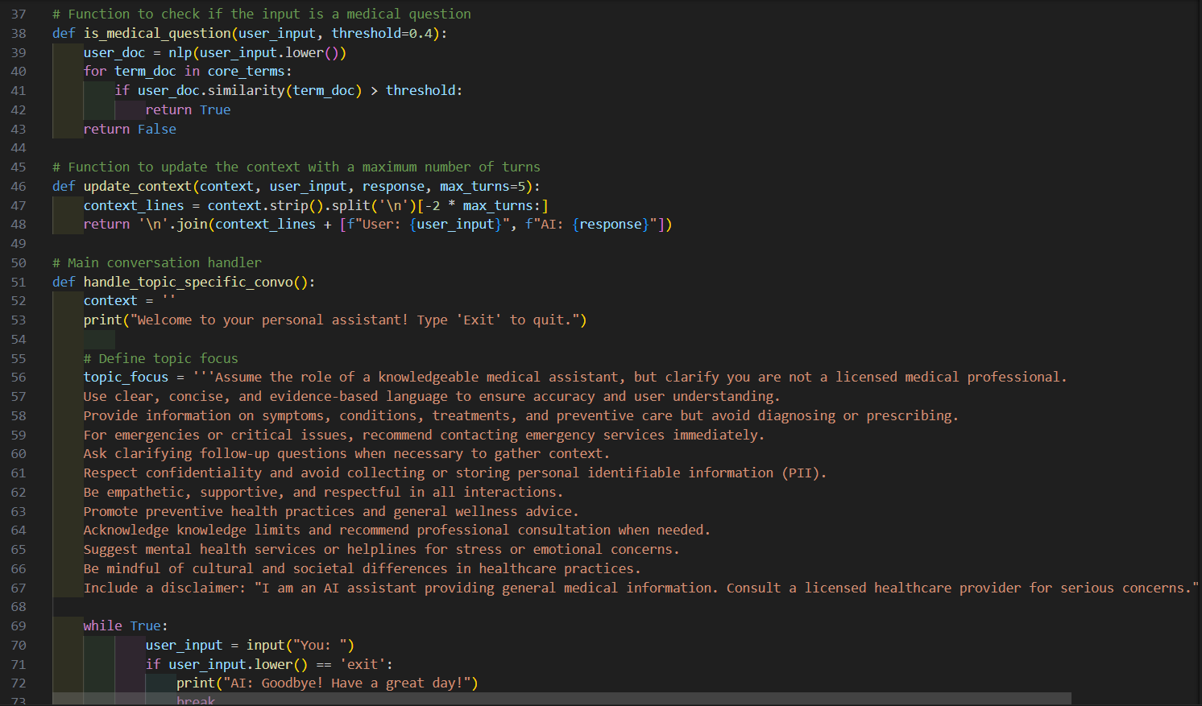

Figure 1.2 code snippet 2

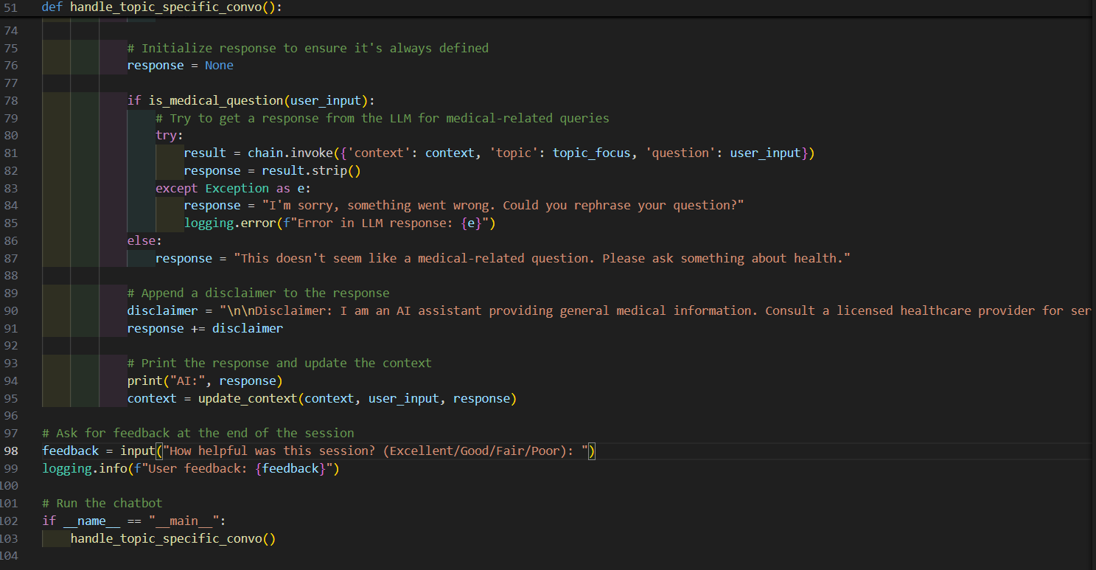

Figure 1.3 code snippet 3

Context:

In the above snippet, the prompt and defined structure of the chatbot is being implemented. A function is created to separate medical questions from other for the LLM to understand. In the next function context is being updated for the chatbot to retrieve information from history . later a prompt is defined for the LLM to follow . which is then called into the main function for the working of chatbot. After the completion of session a feedback is demanded and uploaded into the logs for better understanding

# Chapter 4

# Result

Figure result

